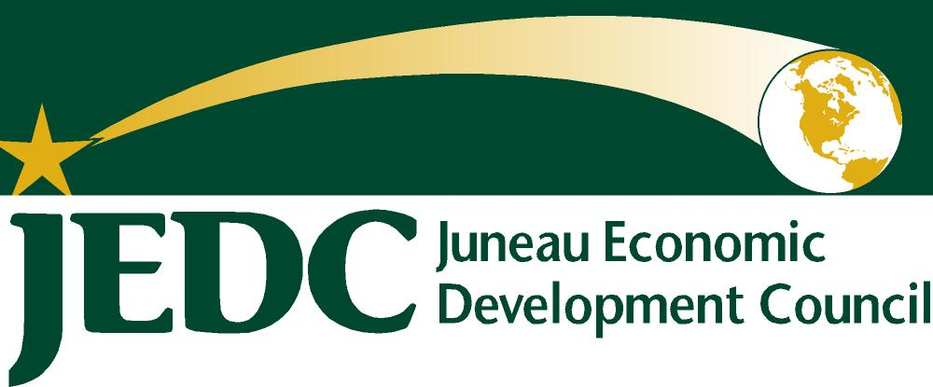
JEDC.org
612 West Willoughby Ave. Suite A
Juneau, AK 99801
Phone 907-523-2300
Fax 907-463-3929

Downtown Revitalization Meeting Summary
JEDC Conference Room
November 9, 2011, 3:30-5:00PM

Attendees:
The meeting started at approximately 3:30PM and ended around 5:00PM. Donna Powell, James Bibb, Barbara Sheinberg, Lorene Palmer, Sean Boily, Dave Hurlet, Jill Ramiel, Greg Fisk, Richard Burns, Heather Marlow, Dale Pernula, Brian Holst, and Margo Waring attended. The meeting was facilitated by Brian Holst, of the Juneau Economic Development Council.
Meeting Purpose and Agenda
The meeting was called by the Juneau Economic Development Council to “revisit efforts to Revitalize Downtown Juneau”, recognizing that this is an issue that many have worked on in the past and continue to work on in different ways currently. The following agenda was provided to participants and used as a guide for the discussion:
- Introductions
- Review work to date
- Anchorage Downtown Partnership, Chris Schutte, Executive Director
- Affirm/Develop a shared a Common understanding of the Core Problem (or Shared Vision)
- Next Steps: Agree on a process to address our problem (or achieve our Vision)
Review Work to Date
After introductions, attenders reviewed the work of prior meetings on the topic of downtown revitalization: statement of core problem and issues facing downtown. Notice was made of projects undertaken or completed since the last meeting in April, including the downtown garage, parking changes, the Willoughby District plan project, dock restructuring, Housing First initiative for chronic inebriates, JAHC’s interest in facility expansion, and new Visitors’ Center.
Chris Schutte, Anchorage Downtown Partnership
Chris Schutte, Executive Director of the Anchorage Downtown Partnership (ADP), addressed the group telephonically, reviewing the legal status of the non-profit and its history, which started in 1996 and has been renewed periodically. This is a special assessment district under municipal code with responsibility for a clean, safe and vital area. The board is working on a strategic plan for the next 5 years. Mr. Schutte responded to questions about “clean and safe”,” including graffiti abatement, litter pick up, the use of trained security guards and relations with the police force. In the winter, security focuses on the health and safety of street people. Sixty-three percent of revenues come from the 1.5 mill special assessment with the remainder from grants, dues, event revenue. In many respects, the Partnership functions as a sub agency of the Municipality.
Downtown housing is also a priority of the Partnership and they have worked with AHFC, Anchorage Community Development Authority, and Cook Inlet Housing Authority for public/private partnerships for more affordable housing for young professionals and others in the downtown area. Financing challenges were discussed. Following up prior work on site selection for larger business, they are now starting small business recruitment, often as secondary locations for successful businesses.
Mr. Schutte noted that many other cities have engaged in downtown revitalization and mentioned such resources as the International Downtown Association. Mr. Schutte kindly expressed his willingness to be a resource.
Affirm/Develop a shared a Common understanding of the Core Problem (or Shared Vision)
Brian asked the group if the core problem statement developed in February was still appropriate. “Fewer and fewer citizens of Juneau consider or utilize downtown as a center for living, leisure and business year round.” There was general agreement with the addition of need for discussion of a longer term vision and a state capital component.
Next Steps
The group supported JEDC’s staff support and the need for further discussion. The following people volunteered to set an agenda for the next meeting December 2, 2011: a member of the Northwind group, Barb Sheinberg, Greg Fisk, and Jill Ramiel.

